CIE
COPYRIGHT INFORMATION EXTRACTION FORM
TITLE: Managing and Governing Product Data in Modern Enterprises Using Semarchy xDM
SCHOOL: Chitkara University, Rajpura, Punjab
Name: Shreyashi Singh
Roll No/ Employee Code: 2210992348

All MEMBERS DETAILS INCLUDING SUPERVISOR
NAME | EMP CODE/ROLL | ADDRESS WITH EMAIL AND MOBILE NO.
Shreyashi Singh | 2210992348 | Email: shreyashi2348.be22@chitkara.edu.in  Phone: +91 8423184001
Ishaan Singla | 2210992582 | Email: ishaan2582.be22@chitkara.edu.in  Phone: +91 9501728176
Aditya Sharma | 2210992588 | Email: aditya2588.be22@chitkara.edu.in  Phone: +91 8295850305
Lakshmesh Sahu | 2210991844 | Email: lakshmesh1844.be22@chitkara.edu.in  Phone: +91 9959306560
Harshit Sharma | 2210991640 | Email: harshit1640.be22@chitkara.edu.in  Phone: +91 8295850305
Dr. Isha Kansal  Mentor | CET1001265 | Email: isha.kansal@chitkara.edu.in

ABSTRACT

  - Problem Background
In enterprises, product information is handled by different departments, applications and data warehouses. which creates a fragmented and inconsistent product information scenario. In the case of XYZ Logistics Limited, there are a number of challenges, including different product codes, redundant data, and missing product descriptions, and the absence of a unified control and governance structure. These issues result in inefficient procurement, inventory management, and compliance issues. This also hinders the ability of the organization to seamlessly integrate with other systems and/or customer channels. Since scale and complexity of the logistics operations increase, the absence of a centralized and trusted product information system becomes a significant barrier to achieving efficiency, accuracy, and responsiveness.

  - Objective of the Project
The aim of this project is to conceptualize and design a unified product data governance framework for ABZ Logistics Limited. The project aims at eliminating inconsistencies, providing quality data, eliminating duplication, and establishing a single source of product data for better performance and regulatory compliance.
Key Challenges Identified:
- Inconsistent Product Codes and Descriptions:
Each warehouse uses its own format for product identification — some have SKU-based, others legacy codes, resulting in mismatched data across systems.
- Duplicate Records:
Product data redundancies cause procurement inefficiencies and inflated inventory counts.
- Lack of Centralized Governance:
Absence of clear data ownership, stewardship workflows, and approval processes creates compliance and reporting risks.
- Integration Difficulties:
Product data structured differently across systems hinders integration with partner networks, e-commerce portals, and ERP software.

  - Proposed Solution / System Overview
Proposed system includes a centralized Product Data Management and Governance Hub, which is intended to bring together disparate product information into a unified environment. The system works through various key functional components, including standardized data modeling, quality validation rules, duplicate detection, metadata-based configurations, and approval-based data stewardship. The system also includes integration components that enable the hub to communicate and share information with other enterprise systems & with governance components that provide clarity around ownership and authorization. Components are designed to work ensuring accurate product documentation and provide a consistent and trusted source of information. The system is also designed in a way that allows for enhancements and makes the system scalable.
Key Implementation Steps
- Ingesting & Validating data via ETL pipelines
- Data Consolidation & Onboarding
- Data Matching & Survivorship
- Data Standardization & Enrichment
- Data Governance & Stewardship
- Golden Record Creation
- Data Publication & Integration

  - Key Features or Functionality
This includes automated validation and cleansing tools, rules-based detection of inconsistencies, and structured workflows to support review and approval by the steward. The system also includes intuitive tools to support the creation and maintenance of product information and displays to show data quality metrics and governance compliance. Synchronization is also added to ensure that product information is consistent across systems. This set of tools and features ensures that product information is consistent and available.

Category | Functionality | Business Outcome
Data Profiling | Analyze and assess data quality | Identify inconsistencies early
Data Matching & Merging | Fuzzy logic and survivorship rules | Remove duplicates
Governance Workflows | Role-based review & approval | Enforced accountability
Data Standardization | Validation & transformation rules | Uniform product coding
Golden Record Management | Create authoritative master records | Trusted enterprise reference
Integration | REST APIs, data exports | Unified data across systems

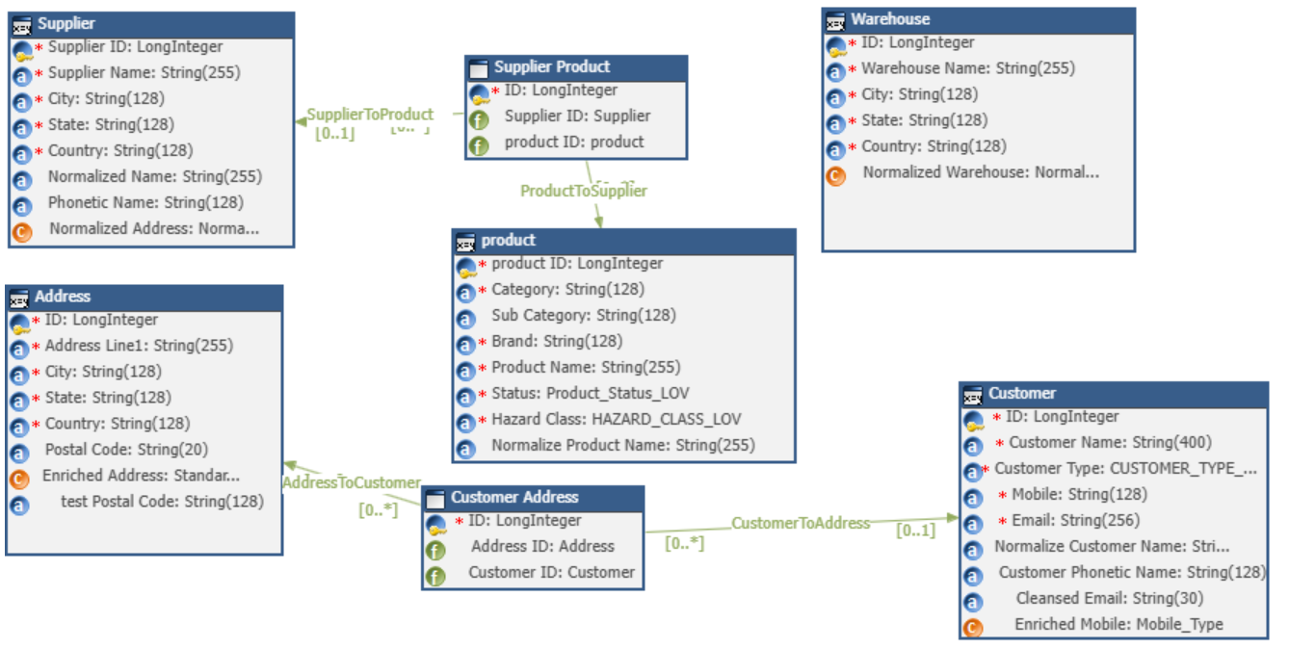
  - Technology / Method Used
The solution is based on data standardization, automated matches, and workflow orchestration. The solution is based on a low code configuration. In addition, integration methodologies, such as APIs, are used to allow free flow of product data between existing applications in the enterprise.

  - Expected Outcome & Benefits
This system is expected to yield a single source of truth for product information with minimal duplication, improved accuracy, and better governance. This means that there is improved procurement and operation efficiency, regulatory compliance, and confidence in enterprise reporting. Real-time and clean data enable faster decisions and improved collaboration across warehouses and partner networks. The approach is also scalable to the organization’s growth, enabling product information to become a key driver of digital transformation, operation excellence, and customer experience
Before Semarchy xDM | After Semarchy xDM Implementation
Fragmented product data across 5 systems | Centralized, synchronized product hub
25% duplicate or inconsistent records | 98% data accuracy and consistency
Manual governance processes | Automated workflows and approvals
Compliance gaps in product labeling | End-to-end traceability and audit trails
Complex system integrations | Simplified API-driven data sharing

  - Original Contribution Statement
This project provides a tailored, domain-specific framework for governing product data in logistics, emphasizing structured stewardship, automated quality controls, and scalable data unification principles.

